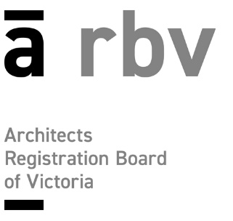

DIRECTOR STATUTORY DECLARATION

Note: Each architect Director registered with the ARBV must complete an individual form

NAME OF COMPANY __________________________________________________

DIRECTOR DECLARATION

The following declaration must be signed in the presence of a person authorised to witness Statutory Declarations.

I, as a director of the above named company, do solemnly and sincerely declare that the application of ___________________________________[company name] to the Architects Registration Board of Victoria for company approval is true and correct and I make it knowing that making a statutory declaration that I know to be untrue is an offence.

Full Name _________________________________________________________________

Signature __________________________________________________________________

Declared at _________________________________________________________________

in the State of ____________________this ________________day of _____________ 20__

before me ___________________________ _________________________________
Signature of witness

Full name & address of witness and qualification to take a declaration:

Please see the Department of Justice and Community Safety for more details on who can witness statutory declarations, www.justice.vic.gov.au/statdecs
Privacy laws and collection of personal information.

The information collected on this form is required by the Architects Act 1991 and the Architects Regulations 2015 for the consideration of company approval. Some of this information will be published in the Register of Architects available on our website www.arbv.vic.gov.au. This information may also be provided to equivalent regulators in other jurisdictions for the purpose of a mutual recognition application.

